**Recurring Neural Networks**

**Motivation**

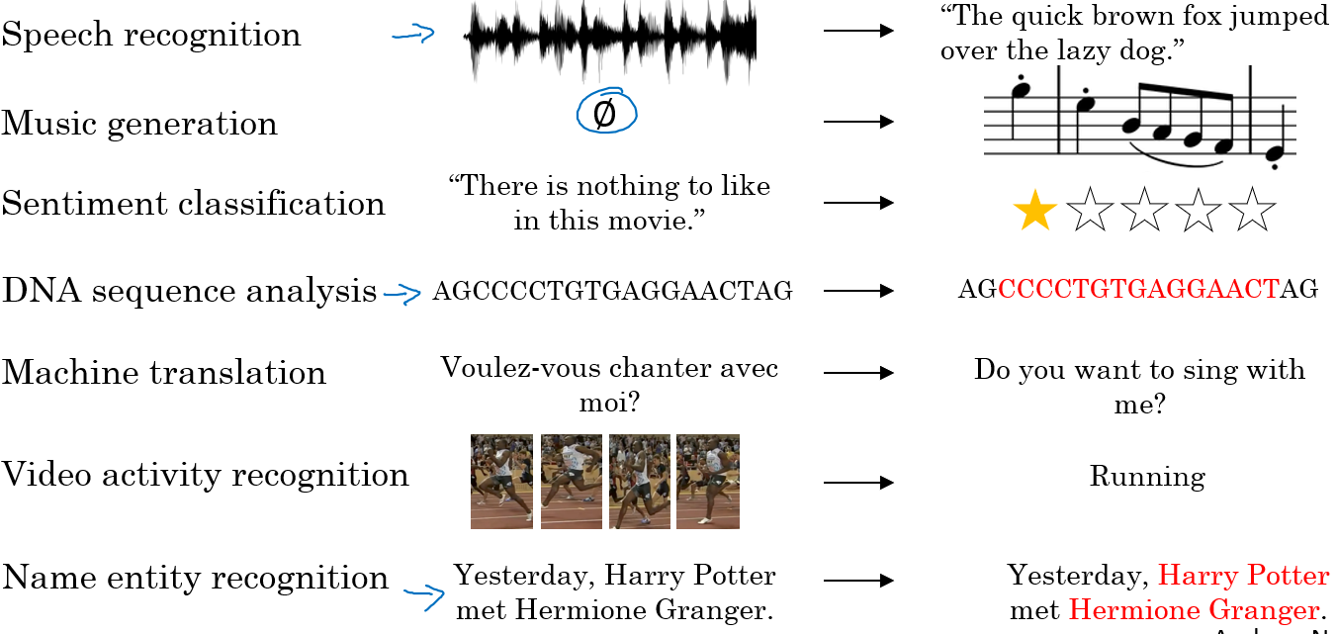

**Definition of RNN**

processing it word by word—or rather, eye saccade by eye saccade—while keeping memories of what came before; this gives you a fluid representation of the meaning conveyed by this sentence. Biological intelligence processes information incrementally while maintaining an internal model of what it’s processing, built from past information and constantly updated as new information comes in.

it processes sequences by iterating through the sequence elements and maintaining a *state* containing information relative to what it has seen so far. In effect, an RNN is a type of neural network that has an internal loop

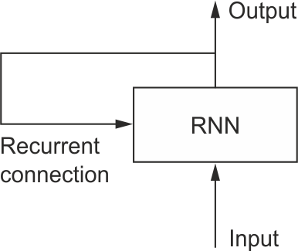

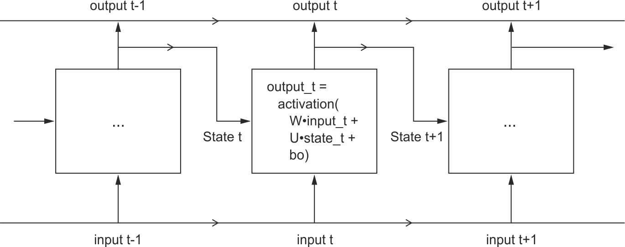

**Example- Name Entity Recognition**

Named-entity recognition and this is used by search engines for example, to index all of say the last 24 hours news of all the people mentioned in the news articles so that they can index them appropriately

These recognition systems can be used to find

* people's names,
* companies names,
* times,
* locations,
* countries names,
* currency names,

**Trump and Modi have signed agreement(NLP)**

**X is the input of all the words – sequence of 6 words- One Hot Vector**

**Y to predict whether the word is part of person name- One hot vector**

**Why RNN**

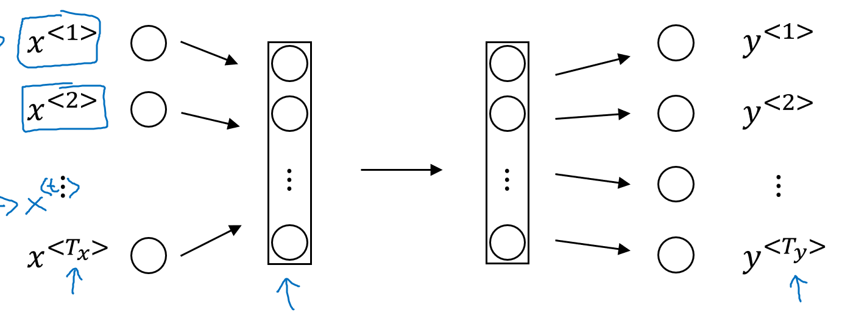

**Problems with feedforward network**

* Inputs, outputs can be different lengths in different examples
* Doesn’t share features learned across different positions of text

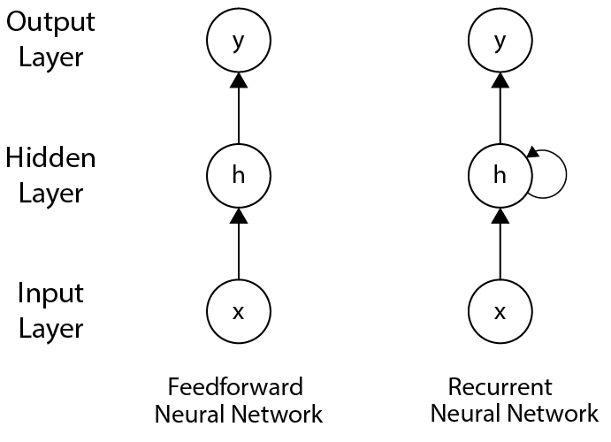

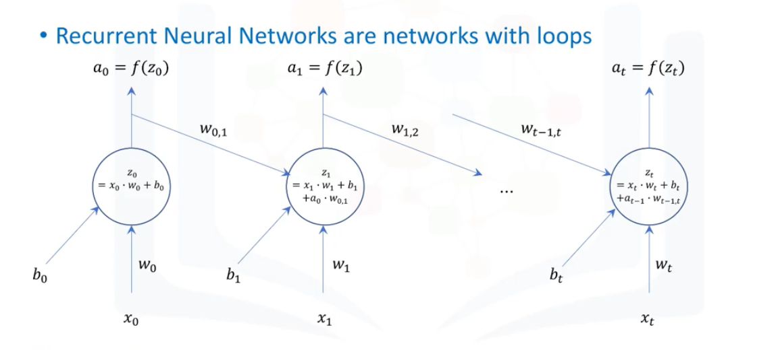

sequential data, such as time series, text, audio, speech, video, weather

**natural language processing** (**NLP**) tasks, such as language translation, sentiment analysis, text generation

The Sun rises in the

